**D. Y. Patil College of College of Engineering and Technology, Kolhapur**

**Department of Computer Science & Engineering**

**Class: SY-A Subject: AOOC**

**Experiment no: 15**

**Group No. G21 Mini Project**

**Title of Mini-Project: Money / Expense Tracker**

**Problem Statement:**

Managing personal finances can be challenging without a clear record of income and expenses. Many individuals struggle to track where their money goes each month. This project aims to provide a simple desktop-based money tracker that allows users to log transactions, monitor their balance, and analyze monthly spending. By storing data locally, it ensures persistent access to financial history for better budgeting decisions.

**Introduction:**

The Money Tracker application is a Java-based desktop project developed to assist users in efficiently managing their personal finances. In today’s fast-paced world, it’s easy to lose track of daily expenses, leading to poor budgeting and savings. This application provides a simple yet powerful solution to this problem by offering a structured way to record and monitor income and expenditure.

Developed using Java Swing for the graphical user interface, the application ensures an interactive and user-friendly experience. Users can quickly add transactions by specifying the type (Income or Expense), amount, category, and a short description. The application records the date automatically and stores all data in a local file (transactions.txt), allowing users to retain their financial history across sessions without the need for a database.

A major feature of this project is the dynamic balance calculation, which updates the user’s total balance in real time based on the added transactions. The data is neatly displayed in a tabular format for easy reference. Additionally, the app supports filtering by month, enabling users to analyze their monthly spending patterns. A “Monthly Report” feature summarizes expenses by category, giving valuable insights into spending habits and helping users make informed financial decisions.

This project also highlights important Java programming concepts such as file handling, object-oriented programming, event-driven design, and GUI development. It’s a practical demonstration of how technology can simplify everyday money management and promote better financial discipline.

**System Architecture:**

**1. Presentation Layer (User Interface)**

* **Built using Java Swing.**
* **Components: JFrame, JPanel, JTable, JComboBox, JLabel, JButton, JOptionPane.**
* **Handles all user interactions like adding transactions, filtering data, and generating reports.**
* **Displays transaction table and balance to the user.**

**2. Business Logic Layer**

* **Contains logic for:**
  + **Adding transactions.**
  + **Calculating balance.**
  + **Filtering by month.**
  + **Generating category-wise expense reports.**
* **Manages the list of transactions using an in-memory List<Transaction>.**

**3. Data Layer (Persistence)**

* **Uses a plain text file (transactions.txt) for storing data.**
* **On startup, transactions are loaded from the file.**
* **On each new entry, transactions are appended to the file.**
* **Handles reading from and writing to the file using BufferedReader and BufferedWriter.**

**4. Model Layer**

* **Contains the Transaction class:**
  + **Fields: type, amount, category, description, and date.**
  + **Methods for serialization (toString) and deserialization (fromString).**

**System Architecture Diagram:**

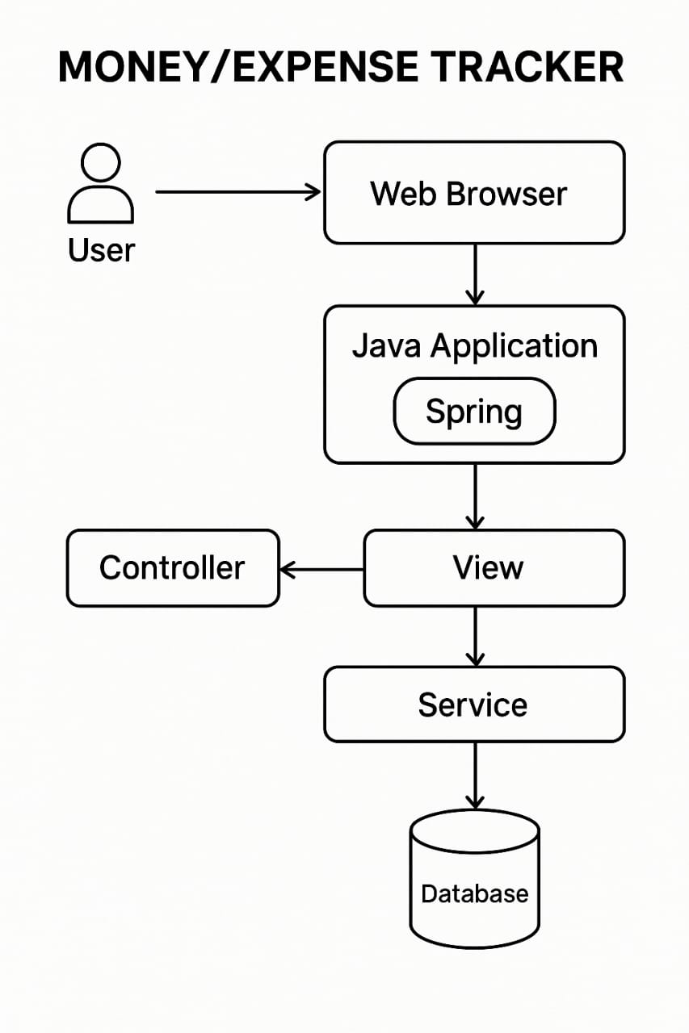

**Module description or working of system:**

1. **Transaction Recording System**The system allows users to add income or expense transactions by providing details such as amount, category, and description, which are saved locally in a text file (transactions.txt).
2. **Dynamic Balance Calculation**The system calculates and displays the user's current balance dynamically by summing incomes and subtracting expenses from the transaction history***.***
3. **Transaction Table Display**All recorded transactions are displayed in a table format with columns for date, type, amount, category, and description, enhancing readability and tracking.
4. **Monthly Filter and Reporting System**Users can filter transactions by month using a dropdown menu, and generate a monthly expense report grouped by category through a dedicated report button.
5. **Persistent Data Storage**The application maintains transaction history across sessions by loading data from and saving to a local text file, ensuring user data is not lost on exit.

**Screenshots:**

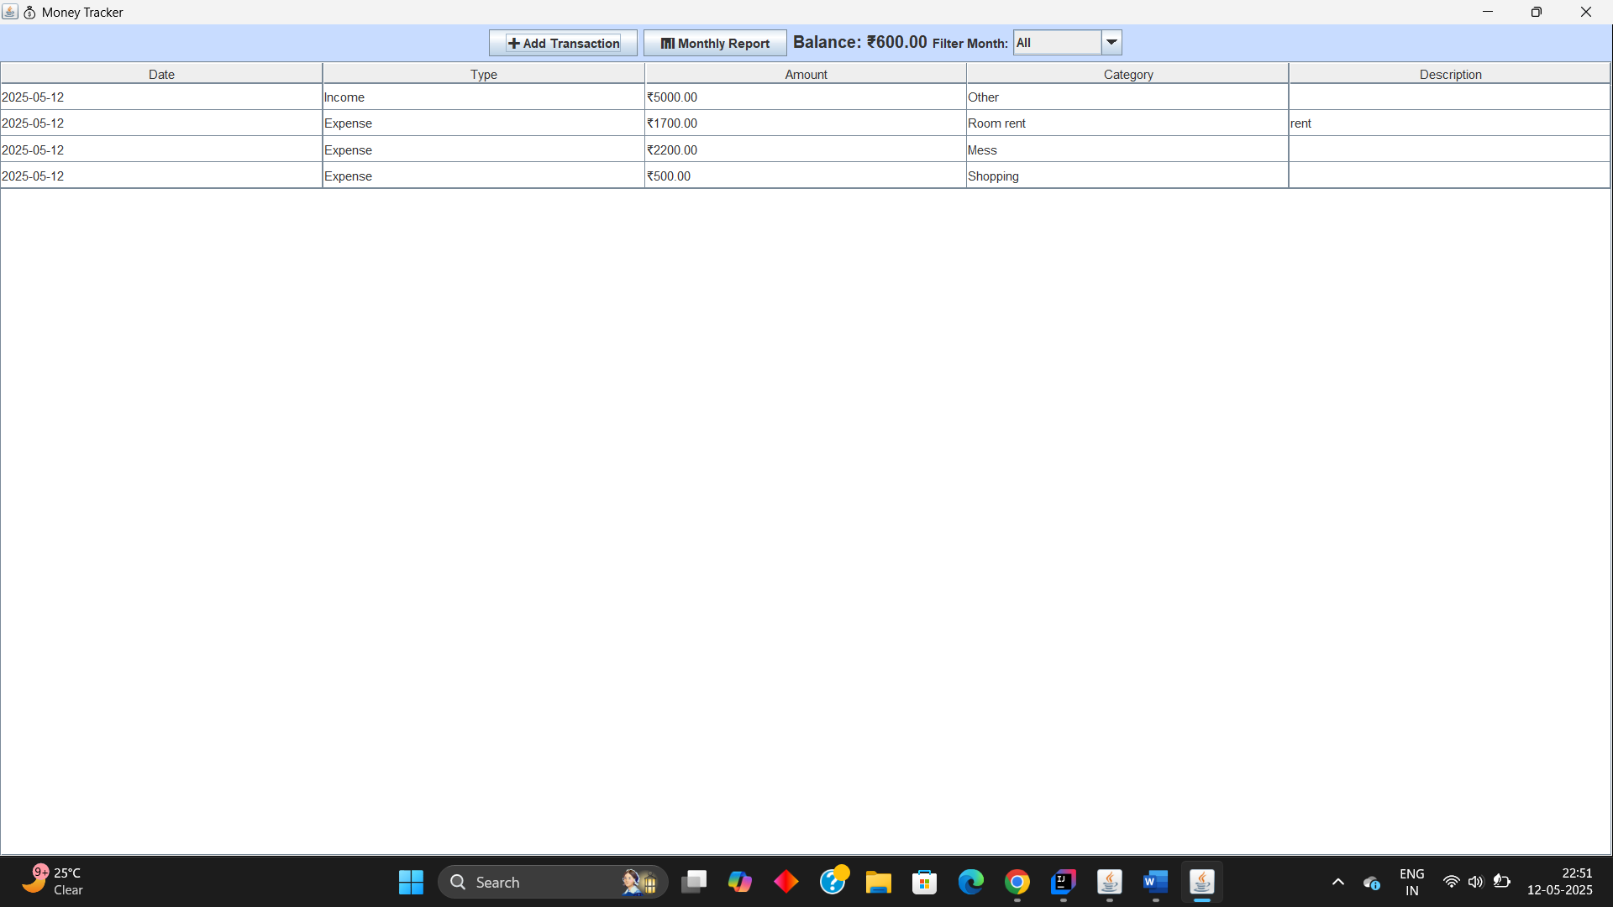

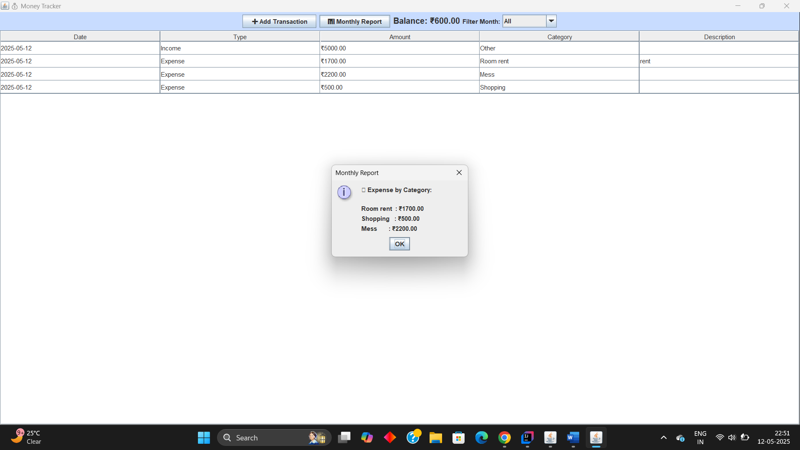

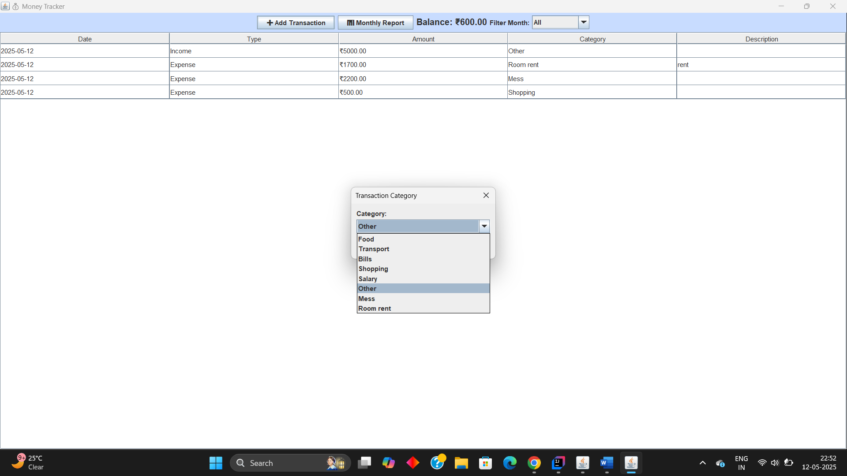

**Group Members:**

|  |  |  |  |
| --- | --- | --- | --- |
| **Unique id** | **Roll No** | **Name of Student** | **Sign** |
| **EN23209764** | **78** | **Vaishnavi Sardar Patil** |  |
| **EN23176935** | **97** | **Shraddha Nilesh Sonawane** |  |
| **EN23247722** | **99** | **Tejashree Chandrakant Jadhav** |  |
| **EN23264023** | **100** | **Vaishnavi Kashinath Gavade** |  |
|  |  |  |  |